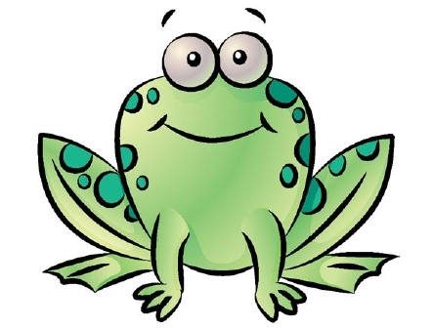
Plan d’un texte descriptif (un animal)

3. Son habitat:
- le climat ____________
- sa nourriture __________________
______________________________

1. Introduction:
- son nom ____________
- son âge _____________
- faits intéressants
______________________________________________________________________________

2. Les aspects physiques:
- ses yeux _______________
- sa taille ________________
- sa couleur ______________
- son poil ________________
- ses oreilles ______________
- sa queue ________________

4. Sa personnalité:
-une activité qu’il fait qui est intéressante ou amusante
________________________________________________________

5. Conclusion:
-Pourquoi aimes-tu cet animal? ____________________________________________________________
- d’autres faits intéressants
____________________________________________________________

1. Introduction:
- son nom ____________
- son âge _____________
- faits intéressants
______________________________________________________

____________________________________________________________________________________________________________________________________________________________________________________________________________________________________________________________________________________________________________________________________________________

2. Les aspects physiques:
- ses yeux _______________
- sa taille ________________
- sa couleur ______________
- son poil ________________
- ses oreilles ______________
- sa queue ________________

_________________________________________________________________________________________________________________________________________________________________________________________________________________________________________________________________________________________________________
3. Son habitat:
- le climat ____________
- sa nourriture __________________
______________________________

_____________________________________________________________________________________________________________________________________________________________________________________________________________________________________________________________________________________________________________________
4. Sa personnalité:
-une activité qu’il fait qui est intéressante ou amusante
________________________________________________________

_________________________________________________________________________________________________________________________________________________________________________________________________________________________________________________________________________________________________________
5. Conclusion:
-Pourquoi aimes-tu cet animal? __________________________________

- d’autres faits intéressants
__________________________________

_____________________________________________________________________________________________________________________________________________________________________________________________________________________________________________________________________________________________________________________

